Beauty Device Market – Global Industry Analysis, Size, Share, Growth, Trends and Forecast, 2026 – 2036
An introduction to TMR  Transparency Market Research (TMR) is a premier provider of syndicated research reports, custom research reports, and consulting services. We deliver a complete packaged solution, which combines current market intelligence, statistical anecdotes, technology inputs, valuable growth insights, aerial view of the competitive framework, and future market trends.  Published Reports  2,500+  Domain Covered  25  Clients Engaged  350+  Analysts Team  400+   |  |  | Taxonomy Defined  By Device Type  By Technology Type  By Application Area  By End User  By Sales Channel  By Region  Report delivery Distribution format; PPT converted to PDF
Research Capabilities  - Pharmaceuticals  - Medical Devices  - Chemicals & Materials  - Technology & Media  - Energy & Mining  - Food & Beverages  - Semiconductor & Electronics  - Consumer Goods  - Biotechnology  - Healthcare IT  - Metals & Minerals  - Defense & Aeronautics  - Packaging | Sector Coverage  - Syndicate Research  - Custom Research  - Consulting Services

 | By Device Type
- At-Home Beauty Devices  - Facial Cleansing & Preparation Devices  - Sonic Facial Cleansing Brushes  - Pore Cleansing Devices  - Facial Steamers  - Exfoliation & Resurfacing Devices  - Ultrasonic Skin Scrubbers  - Microdermabrasion Devices  - Dermaplaning Devices  - LED & Light Therapy Devices  - LED Face Masks  - LED Light Therapy Wands  - LED Light Therapy Panels  - Skin Firming & Lifting Devices  - Microcurrent Facial Devices  - Radiofrequency (RF) Skin Tightening Devices  - Electrical Muscle Stimulation (EMS) Facial Devices  - Ultrasound Facial Treatment Devices  - Multi-Technology Facial Devices  - Acne & Skin Treatment Devices  - High-Frequency Facial Devices  - Thermal Acne Treatment Devices  - Facial Cooling & Cryotherapy Devices  - Hydration & Skin Infusion Devices  - Facial Nano-Mist Sprayers  - Ultrasonic Skin Infusion Devices  - Facial Hydration Devices  - Hair Removal Devices  - IPL Hair Removal Devices  - Laser Hair Removal Devices  - Electric Epilators  - Hair & Scalp Treatment Devices  - Laser Hair Growth Caps  - Laser Hair Growth Combs  - Scalp Massagers  - Scalp Cleansing Devices  - Other At-Home Beauty Devices  - Eye Care Devices  - Facial Massage Devices  - Other Beauty Treatment Devices  - Professional Beauty & Aesthetic Equipment  - Laser Aesthetic Equipment  - Laser Hair Removal Systems  - Laser Skin Resurfacing Systems |  |  | - Laser Pigmentation Treatment Systems  - IPL & Light-Based Aesthetic Equipment  - IPL Hair Removal Systems  - IPL Skin Rejuvenation Systems  - Professional LED Phototherapy Systems  - Skin Tightening & Body Contouring Equipment  - Radiofrequency (RF) Skin Tightening Systems  - High-Intensity Focused Ultrasound (HIFU) Systems  - Electromagnetic Muscle Stimulation Body Contouring Systems  - Multi-Technology Body Contouring Systems  - Professional Facial Treatment Equipment  - Microdermabrasion Systems  - Hydradermabrasion Systems  - Oxygen Facial Systems  - Professional Skin Infusion Systems  - Microneedling & Skin Rejuvenation Equipment  - Automated Microneedling Devices  - RF Microneedling Systems  - Other Professional Aesthetic Equipment  - Professional Cryotherapy Equipment  - Professional Hair & Scalp Treatment Systems  - Other Specialized Aesthetic Equipment
 | By Technology Type |  |  | By Application Area
- LED & Light Therapy Technology  - LED Light Therapy  - Intense Pulsed Light (IPL)  - Laser Technology  - Ablative Laser  - Non-Ablative Laser  - Low-Level Laser Therapy (LLLT)  - Radiofrequency (RF) Technology  - Monopolar RF  - Bipolar RF  - Multipolar RF  - RF Microneedling  - Electrical Stimulation Technology  - Microcurrent  - Electrical Muscle Stimulation (EMS)  - High-Frequency Current  - Ultrasound & Sonic Technology  - Sonic Vibration  - Ultrasonic Cleansing & Exfoliation  - Ultrasonic Infusion  - High-Intensity Focused Ultrasound (HIFU)  - Mechanical & Abrasive Technology  - Mechanical Cleansing & Exfoliation  - Microdermabrasion  - Dermaplaning  - Mechanical Hair Removal  - Thermal & Cryotherapy Technology  - Thermal Treatment  - Cryotherapy  - Hydration & Infusion Technology  - Hydradermabrasion  - Oxygen Infusion  - Nano-Mist Atomization  - Combination Technology  - Other Technologies |  |  | - Facial Cleansing & Skin Preparation  - Facial Cleansing  - Pore Cleansing  - Skin Preparation  - Skin Exfoliation & Resurfacing  - Skin Exfoliation  - Skin Resurfacing  - Skin Texture Improvement  - Acne Treatment & Management  - Acne Treatment  - Acne Prevention & Maintenance  - Skin Rejuvenation, Firming & Lifting  - Fine Lines & Wrinkle Reduction  - Skin Tightening & Firming  - Facial Lifting & Contouring  - Skin Hydration & Infusion  - Skin Hydration  - Active Ingredient Infusion  - Pigmentation & Skin Tone Improvement  - Hyperpigmentation Treatment  - Skin Tone & Complexion Improvement  - Hair Removal  - Facial Hair Removal  - Body Hair Removal  - Hair & Scalp Treatment  - Hair Regrowth & Hair Loss Management  - Scalp Care & Treatment  - Body Contouring & Skin Tightening  - Body Contouring  - Body Skin Tightening  - Cellulite Appearance Reduction  - Other Applications  - Eye Area Treatment  - Skin Cooling & Recovery  - Other Specialized Aesthetic Treatments
 | By End-use |  |  | By Sales Channel
- Individual / Home Users  - Personal Beauty & Skincare Users  - Personal Hair Removal Users  - Personal Hair & Scalp Care Users  - Beauty Salons & Spas  - Beauty Salons  - Day Spas  - Medical Spas (Med Spas)  - Aesthetic Clinics & Dermatology Centers  - Dermatology Clinics  - Aesthetic & Cosmetic Clinics  - Plastic Surgery & Cosmetic Surgery Centers  - Wellness & Hospitality Providers  - Wellness Centers  - Hotel & Resort Spas  - Other Professional End Users  - Hospitals & Medical Centers  - Professional Training & Beauty Academies  - Other Specialized Beauty Service Providers |  |  | - Brand-Owned Online Stores  - Third-Party Online Retailers & Marketplaces  - Specialty Beauty Stores  - Department Stores  - Mass Retail Stores  - Professional Direct Sales  - Professional Distributors  - Others
 | By Region |  |  | By Milk Type
- North America
- Latin America
- East Asia
- South Asia & Pacific
- Europe
- Middle East & Africa
- Emerging Countries (25+ Country Wise Data Analysis)

Sample Graphs & Representation  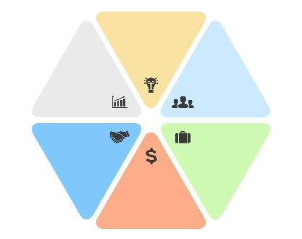  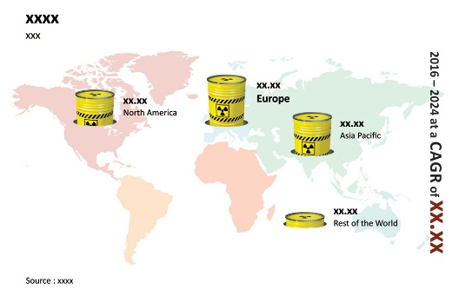  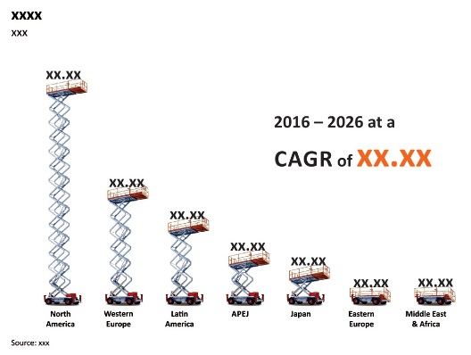  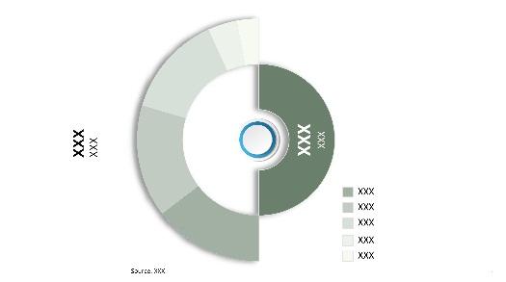  Images are only for illustration purpose  Sample Graphs & Representation  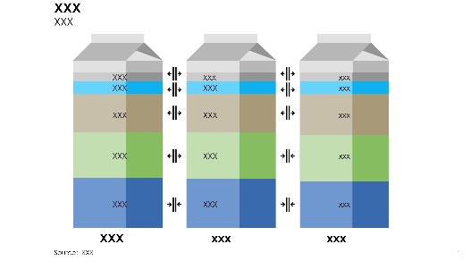  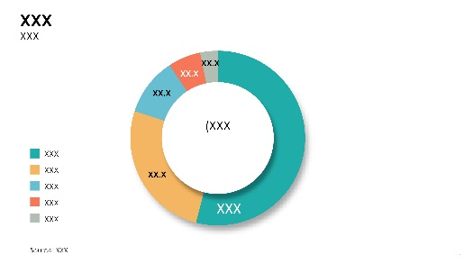  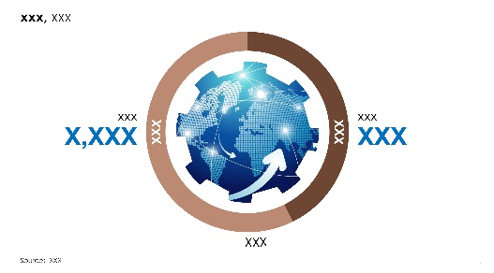  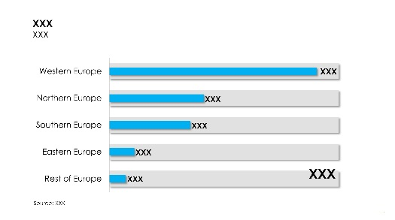  Images are only for illustration purpose  Sample Graphs & Representation  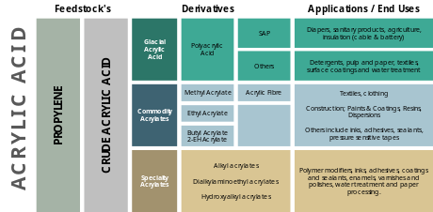  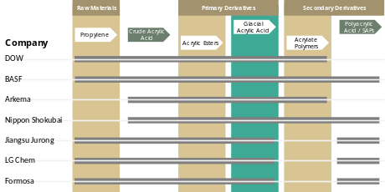  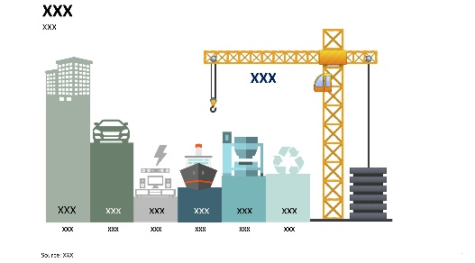  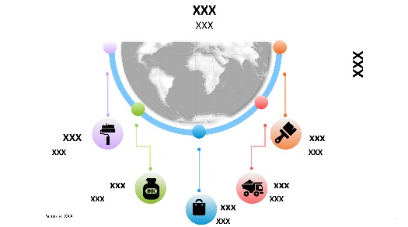  Images are only for illustration purpose  Sample Graphs & Representation  Images are only for illustration purpose  Sample Graphs & Representation  Images are only for illustration purpose  Sample Graphs & Representation  Sample Graphs & Representation  Images are only for illustration purpose  Sample Graphs & Representation  Images are only for illustration purpose  Sample Graphs & Representation  Images are only for illustration purpose  Sample Graphs & Representation  Images are only for illustration purpose  Sample Graphs & Representation  Images are only for illustration purpose  Sample Graphs & Representation  Sample Graphs & Representation  Images are only for illustration purpose  Sample Graphs & Representation  Images are only for illustration purpose |  | - Executive Summary  - Global Market Outlook  - Demand Side Trends  - Supply Side Trends  - Technology Roadmap  - Analysis and Recommendations  - Market Overview  - Market Coverage / Taxonomy  - Market Definition / Scope / Limitations  - Key Market Trends  - Key Trends Impacting the Market  - Product Innovation / Development Trends  - Key Success Factors  - Device Adoption & Usage Analysis  - Product Differentiation, USPs & Features  - Technology, AI Integration & Automation  - Product Safety, Regulatory Compliance & Quality Standards  - Personalization, Flexibility & Customization  - Consumer Survey Analysis and Demand Insights  - Consumer Survey Objectives and Research Scope  - Objectives of Primary Consumer Research for Beauty Devices  - Role of Consumer Survey in Validating Market Sizing, Adoption Trends and Demand Forecasts  - Consumer Needs, Unmet Demand and Market Opportunity Assessment  - Survey Coverage by Device Type, Application Area and Consumer Group  - Survey Methodology Framework  - Research Approach: Quantitative Survey and Qualitative Consumer Interviews  - Sample Design, Respondent Screening and Representativeness  - Geographic Coverage: North America, Latin America, Europe, East Asia, South Asia & Pacific, and Middle East & Africa  - Consumer Cohort Selection  - Current Beauty Device Owners  - Non-Owners  - Prospective Beauty Device Buyers  - Lapsed Beauty Device Users  - Respondent Selection Across Income Groups, Age Groups and Demographics  - Research Tools: Structured Questionnaires, Consumer Interviews and Product Concept Testing  - Respondent Demographic and Socioeconomic Profile  - Age Group Distribution and Beauty Device Ownership  - Gender-Based Beauty Device Awareness and Purchasing Behavior  - Household Income Distribution and Device Affordability  - Urban, Semi-Urban and Rural Consumer Representation  - Beauty & Personal Care Expenditure Patterns  - Consumer Classification by Device Ownership and Purchase Intention  - Consumer Awareness and Familiarity with Beauty Devices  - Consumer Awareness by Beauty Device Category  - Awareness of LED, IPL, RF, Microcurrent and Other Beauty Device Technologies  - Key Product Discovery Sources: Social Media, Dermatologists, Beauty Retailers and Influencers  - Consumer Understanding of Device Features, Safety and Treatment Benefits  - Unaided and Aided Brand Awareness Across Beauty Device Manufacturers  - Global Beauty Device Market Demand Analysis 2021–2025 and Forecast, 2026–2036  - Historical Market Volume (Units) Analysis, 2021–2025  - Current and Future Market Volume (Units) Projections, 2026–2036  - Y-o-Y Growth Trend Analysis  - Global Beauty Device Market - Pricing Analysis  - Regional Price Assessment  - Manufacturer Level Pricing  - Distributor Level Pricing  - Retail Level Pricing  - Segment-wise Price Comparison (Product Type vs Form Type)  - Country-wise Price Comparison (Product Type)  - Price Forecast till 2036  - Factors Impacting Pricing  - Competitor Pricing Strategies  - Global Beauty Device Market Demand (US$ Mn) Analysis 2021–2025 and Forecast, 2026–2036  - Historical Market Value (US$ Mn) Analysis, 2021–2025  - Current and Future Market Value (US$ Mn) Projections, 2026–2036  - Y-o-Y Growth Trend Analysis  - Absolute $ Opportunity Analysis  - Market Background  - Macro-Economic Factors  - Forecast Factors - Relevance & Impact  - Value Chain  - Raw Material Suppliers  - Product Manufacturers  - End Customers  - Market Dynamics  - Drivers  - Restraints  - Opportunity Analysis  - Global Beauty Device Market Outlook, 2021–2036, by Device Type  - Introduction / Key Findings  - Historical Market Size (US$ Mn) and Volume Analysis By Device Type, 2021–2025  - Market Size (US$ Mn) and Volume Analysis and Forecast By Device Type, 2026–2036  - At-Home Beauty Devices  - Facial Cleansing & Preparation Devices  - Sonic Facial Cleansing Brushes  - Pore Cleansing Devices  - Facial Steamers  - Exfoliation & Resurfacing Devices  - Ultrasonic Skin Scrubbers  - Microdermabrasion Devices  - Dermaplaning Devices  - LED & Light Therapy Devices  - LED Face Masks  - LED Light Therapy Wands  - LED Light Therapy Panels  - Skin Firming & Lifting Devices  - Microcurrent Facial Devices  - Radiofrequency (RF) Skin Tightening Devices  - Electrical Muscle Stimulation (EMS) Facial Devices  - Ultrasound Facial Treatment Devices  - Multi-Technology Facial Devices  - Acne & Skin Treatment Devices  - High-Frequency Facial Devices  - Thermal Acne Treatment Devices  - Facial Cooling & Cryotherapy Devices  - Hydration & Skin Infusion Devices  - Facial Nano-Mist Sprayers  - Ultrasonic Skin Infusion Devices  - Facial Hydration Devices  - Hair Removal Devices  - IPL Hair Removal Devices  - Laser Hair Removal Devices  - Electric Epilators  - Hair & Scalp Treatment Devices  - Laser Hair Growth Caps  - Laser Hair Growth Combs  - Scalp Massagers  - Scalp Cleansing Devices  - Other At-Home Beauty Devices  - Eye Care Devices  - Facial Massage Devices  - Other Beauty Treatment Devices  - Professional Beauty & Aesthetic Equipment  - Laser Aesthetic Equipment  - Laser Hair Removal Systems  - Laser Skin Resurfacing Systems  - Laser Pigmentation Treatment Systems  - IPL & Light-Based Aesthetic Equipment  - IPL Hair Removal Systems  - IPL Skin Rejuvenation Systems  - Professional LED Phototherapy Systems  - Skin Tightening & Body Contouring Equipment  - Radiofrequency (RF) Skin Tightening Systems  - High-Intensity Focused Ultrasound (HIFU) Systems  - Electromagnetic Muscle Stimulation Body Contouring Systems  - Multi-Technology Body Contouring Systems  - Professional Facial Treatment Equipment  - Microdermabrasion Systems  - Hydradermabrasion Systems  - Oxygen Facial Systems  - Professional Skin Infusion Systems  - Microneedling & Skin Rejuvenation Equipment  - Automated Microneedling Devices  - RF Microneedling Systems  - Other Professional Aesthetic Equipment  - Professional Cryotherapy Equipment  - Professional Hair & Scalp Treatment Systems  - Other Specialized Aesthetic Equipment  - Market Attractiveness Analysis By Device Type  - Global Beauty Device Market Outlook, 2021–2036, by Technology Type  - Introduction / Key Findings  - Historical Market Size (US$ Mn) and Volume Analysis By Technology Type, 2021–2025  - Market Size (US$ Mn) and Volume Analysis and Forecast By Technology Type, 2026–2036  - LED & Light Therapy Technology  - LED Light Therapy  - Intense Pulsed Light (IPL)  - Laser Technology  - Ablative Laser  - Non-Ablative Laser  - Low-Level Laser Therapy (LLLT)  - Radiofrequency (RF) Technology  - Monopolar RF  - Bipolar RF  - Multipolar RF  - RF Microneedling  - Electrical Stimulation Technology  - Microcurrent  - Electrical Muscle Stimulation (EMS)  - High-Frequency Current  - Ultrasound & Sonic Technology  - Sonic Vibration  - Ultrasonic Cleansing & Exfoliation  - Ultrasonic Infusion  - High-Intensity Focused Ultrasound (HIFU)  - Mechanical & Abrasive Technology  - Mechanical Cleansing & Exfoliation  - Microdermabrasion  - Dermaplaning  - Mechanical Hair Removal  - Thermal & Cryotherapy Technology  - Thermal Treatment  - Cryotherapy  - Hydration & Infusion Technology  - Hydradermabrasion  - Oxygen Infusion  - Nano-Mist Atomization  - Combination Technology  - Other Technologies  - Market Attractiveness Analysis By Technology Type  - Global Beauty Device Market Outlook, 2021–2036, by Application Area  - Introduction / Key Findings  - Historical Market Size (US$ Mn) and Volume Analysis By Application Area, 2021–2025  - Market Size (US$ Mn) and Volume Analysis and Forecast By Application Area, 2026–2036  - Facial Cleansing & Skin Preparation  - Facial Cleansing  - Pore Cleansing  - Skin Preparation  - Skin Exfoliation & Resurfacing  - Skin Exfoliation  - Skin Resurfacing  - Skin Texture Improvement  - Acne Treatment & Management  - Acne Treatment  - Acne Prevention & Maintenance  - Skin Rejuvenation, Firming & Lifting  - Fine Lines & Wrinkle Reduction  - Skin Tightening & Firming  - Facial Lifting & Contouring  - Skin Hydration & Infusion  - Skin Hydration  - Active Ingredient Infusion  - Pigmentation & Skin Tone Improvement  - Hyperpigmentation Treatment  - Skin Tone & Complexion Improvement  - Hair Removal  - Facial Hair Removal  - Body Hair Removal  - Hair & Scalp Treatment  - Hair Regrowth & Hair Loss Management  - Scalp Care & Treatment  - Body Contouring & Skin Tightening  - Body Contouring  - Body Skin Tightening  - Cellulite Appearance Reduction  - Other Applications  - Eye Area Treatment  - Skin Cooling & Recovery  - Other Specialized Aesthetic Treatments  - Market Attractiveness Analysis By Application Area  - Global Beauty Device Market Outlook, 2021–2036, by End User  - Introduction / Key Findings  - Historical Market Size (US$ Mn) and Volume Analysis By End User, 2021–2025  - Market Size (US$ Mn) and Volume Analysis and Forecast By End User, 2026–2036  - Individual / Home Users  - Personal Beauty & Skincare Users  - Personal Hair Removal Users  - Personal Hair & Scalp Care Users  - Beauty Salons & Spas  - Beauty Salons  - Day Spas  - Medical Spas (Med Spas)  - Aesthetic Clinics & Dermatology Centers  - Dermatology Clinics  - Aesthetic & Cosmetic Clinics  - Plastic Surgery & Cosmetic Surgery Centers  - Wellness & Hospitality Providers  - Wellness Centers  - Hotel & Resort Spas  - Other Professional End Users  - Hospitals & Medical Centers  - Professional Training & Beauty Academies  - Other Specialized Beauty Service Providers  - Market Attractiveness Analysis By End User  - Global Beauty Device Market Outlook, 2021–2036, by Sales Channel  - Introduction / Key Findings  - Historical Market Size (US$ Mn) and Volume Analysis By Sales Channel, 2021–2025  - Market Size (US$ Mn) and Volume Analysis and Forecast By Sales Channel, 2026–2036  - Brand-Owned Online Stores  - Third-Party Online Retailers & Marketplaces  - Specialty Beauty Stores  - Department Stores  - Mass Retail Stores  - Professional Direct Sales  - Professional Distributors  - Others  - Market Attractiveness Analysis By Sales Channel  - Global Beauty Device Market Outlook, 2021–2036, by Region  - Introduction  - Historical Market Size (US$ Mn) and Volume Analysis By Region, 2021–2025  - Market Size (US$ Mn) and Volume Analysis and Forecast By Region, 2026–2036  - North America  - Latin America  - Western Europe  - Eastern Europe  - Middle East and Africa (MEA)  - East Asia  - South Asia and Pacific  - Market Attractiveness Analysis By Region  - North America Beauty Device Market Outlook, 2021–2036  - Introduction  - Pricing Analysis  - Historical Market Size (US$ Mn) and Volume Trend Analysis By Market Taxonomy, 2021–2025  - Market Size (US$ Mn) and Volume Forecast By Market Taxonomy, 2026–2036  - By Country  - U.S.  - Canada  - Mexico  - By Device Type  - By Technology Type  - By Application Area  - By End User  - By Sales Channel  - Market Attractiveness Analysis  - By Country  - By Device Type  - By Technology Type  - By Application Area  - By End User  - By Sales Channel  - Market Trends  - Key Market Participants - Intensity Mapping  - Drivers and Restraints - Impact Analysis  - Latin America Beauty Device Market Outlook, 2021–2036  - Introduction  - Pricing Analysis  - Historical Market Size (US$ Mn) and Volume Trend Analysis By Market Taxonomy, 2021–2025  - Market Size (US$ Mn) and Volume Forecast By Market Taxonomy, 2026–2036  - By Country  - Brazil  - Argentina  - Rest of Latin America  - By Device Type  - By Technology Type  - By Application Area  - By End User  - By Sales Channel  - Market Attractiveness Analysis  - By Country  - By Device Type  - By Technology Type  - By Application Area  - By End User  - By Sales Channel  - Market Trends  - Key Market Participants - Intensity Mapping  - Drivers and Restraints - Impact Analysis  - Western Europe Beauty Device Market Outlook, 2021–2036  - Introduction  - Pricing Analysis  - Historical Market Size (US$ Mn) and Volume Trend Analysis By Market Taxonomy, 2021–2025  - Market Size (US$ Mn) and Volume Forecast By Market Taxonomy, 2026–2036  - By Country  - Germany  - Italy  - France  - U.K.  - Spain  - BENELUX  - Rest of Western Europe  - By Device Type  - By Technology Type  - By Application Area  - By End User  - By Sales Channel  - Market Attractiveness Analysis  - By Country  - By Device Type  - By Technology Type  - By Application Area  - By End User  - By Sales Channel  - Market Trends  - Key Market Participants - Intensity Mapping  - Drivers and Restraints - Impact Analysis  - Eastern Europe Beauty Device Market Outlook, 2021–2036  - Introduction  - Pricing Analysis  - Historical Market Size (US$ Mn) and Volume Trend Analysis By Market Taxonomy, 2021–2025  - Market Size (US$ Mn) and Volume Forecast By Market Taxonomy, 2026–2036  - By Country  - Russia  - Hungary  - Poland  - Balkan & Baltics  - Rest of Eastern Europe  - By Device Type  - By Technology Type  - By Application Area  - By End User  - By Sales Channel  - Market Attractiveness Analysis  - By Country  - By Device Type  - By Technology Type  - By Application Area  - By End User  - By Sales Channel  - Market Trends  - Key Market Participants - Intensity Mapping  - Drivers and Restraints - Impact Analysis  - South Asia and Pacific Beauty Device Market Outlook, 2021–2036  - Introduction  - Pricing Analysis  - Historical Market Size (US$ Mn) and Volume Trend Analysis By Market Taxonomy, 2021–2025  - Market Size (US$ Mn) and Volume Forecast By Market Taxonomy, 2026–2036  - By Country  - India  - ASEAN  - Australia and New Zealand  - Rest of South Asia & Pacific  - By Device Type  - By Technology Type  - By Application Area  - By End User  - By Sales Channel  - Market Attractiveness Analysis  - By Country  - By Device Type  - By Technology Type  - By Application Area  - By End User  - By Sales Channel  - Market Trends  - Key Market Participants - Intensity Mapping  - Drivers and Restraints - Impact Analysis  - East Asia Beauty Device Market Outlook, 2021–2036  - Introduction  - Pricing Analysis  - Historical Market Size (US$ Mn) and Volume Trend Analysis By Market Taxonomy, 2021–2025  - Market Size (US$ Mn) and Volume Forecast By Market Taxonomy, 2026–2036  - By Country  - China  - Japan  - South Korea  - By Device Type  - By Technology Type  - By Application Area  - By End User  - By Sales Channel  - Market Attractiveness Analysis  - By Country  - By Device Type  - By Technology Type  - By Application Area  - By End User  - By Sales Channel  - Market Trends  - Key Market Participants - Intensity Mapping  - Drivers and Restraints - Impact Analysis  - Middle East and Africa Beauty Device Market Outlook, 2021–2036  - Introduction  - Pricing Analysis  - Historical Market Size (US$ Mn) and Volume Trend Analysis By Market Taxonomy, 2021–2025  - Market Size (US$ Mn) and Volume Forecast By Market Taxonomy, 2026–2036  - By Country  - GCC Countries  - Turkiye  - Northern Africa  - South Africa  - Rest of Middle East and Africa  - By Device Type  - By Technology Type  - By Application Area  - By End User  - By Sales Channel  - Market Attractiveness Analysis  - By Country  - By Device Type  - By Technology Type  - By Application Area  - By End User  - By Sales Channel  - Market Trends  - Key Market Participants - Intensity Mapping  - Drivers and Restraints - Impact Analysis  - Country Wise Beauty Device Market Analysis  - U.S. Beauty Device Market Analysis  - By Device Type  - By Technology Type  - By Application Area  - By End User  - By Sales Channel  - Canada Beauty Device Market Analysis  - By Device Type  - By Technology Type  - By Application Area  - By End User  - By Sales Channel  - Mexico Beauty Device Market Analysis  - By Device Type  - By Technology Type  - By Application Area  - By End User  - By Sales Channel  - Brazil Beauty Device Market Analysis  - By Device Type  - By Technology Type  - By Application Area  - By End User  - By Sales Channel  - Argentina Beauty Device Market Analysis  - By Device Type  - By Technology Type  - By Application Area  - By End User  - By Sales Channel  - Germany Beauty Device Market Analysis  - By Device Type  - By Technology Type  - By Application Area  - By End User  - By Sales Channel  - Italy Beauty Device Market Analysis  - By Device Type  - By Technology Type  - By Application Area  - By End User  - By Sales Channel  - France Beauty Device Market Analysis  - By Device Type  - By Technology Type  - By Application Area  - By End User  - By Sales Channel  - U.K. Beauty Device Market Analysis  - By Device Type  - By Technology Type  - By Application Area  - By End User  - By Sales Channel  - Spain Beauty Device Market Analysis  - By Device Type  - By Technology Type  - By Application Area  - By End User  - By Sales Channel  - BENELUX Beauty Device Market Analysis  - By Device Type  - By Technology Type  - By Application Area  - By End User  - By Sales Channel  - Nordics Beauty Device Market Analysis  - By Device Type  - By Technology Type  - By Application Area  - By End User  - By Sales Channel  - Russia Beauty Device Market Analysis  - By Device Type  - By Technology Type  - By Application Area  - By End User  - By Sales Channel  - Hungary Beauty Device Market Analysis  - By Device Type  - By Technology Type  - By Application Area  - By End User  - By Sales Channel  - Poland Beauty Device Market Analysis  - By Device Type  - By Technology Type  - By Application Area  - By End User  - By Sales Channel  - Balkan & Baltics Beauty Device Market Analysis  - By Device Type  - By Technology Type  - By Application Area  - By End User  - By Sales Channel  - China Beauty Device Market Analysis  - By Device Type  - By Technology Type  - By Application Area  - By End User  - By Sales Channel  - Japan Beauty Device Market Analysis  - By Device Type  - By Technology Type  - By Application Area  - By End User  - By Sales Channel  - S. Korea Beauty Device Market Analysis  - By Device Type  - By Technology Type  - By Application Area  - By End User  - By Sales Channel  - India Beauty Device Market Analysis  - By Device Type  - By Technology Type  - By Application Area  - By End User  - By Sales Channel  - ASEAN Beauty Device Market Analysis  - By Device Type  - By Technology Type  - By Application Area  - By End User  - By Sales Channel  - Australia and New Zealand Beauty Device Market Analysis  - By Device Type  - By Technology Type  - By Application Area  - By End User  - By Sales Channel  - Turkiye Beauty Device Market Analysis  - By Device Type  - By Technology Type  - By Application Area  - By End User  - By Sales Channel  - GCC Beauty Device Market Analysis  - By Device Type  - By Technology Type  - By Application Area  - By End User  - By Sales Channel  - Northern Africa Beauty Device Market Analysis  - By Device Type  - By Technology Type  - By Application Area  - By End User  - By Sales Channel  - South Africa Beauty Device Market Analysis  - By Device Type  - By Technology Type  - By Application Area  - By End User  - By Sales Channel  - Market Structure Analysis  - Market Analysis by Tier of Companies  - Market Share Analysis of Top Players  - Market Presence Analysis  - Competition Analysis  - Competitive MNC  - NuFACE  - Tria Beauty  - SolaWave  - Therabody  - Neutrogena (Johnson & Johnson)  - Dermalogica  - Trophy Skin  - Silk’n USA  - Conair  - Remington Personal Care  - Philips  - FOREO  - Dyson  - Braun  - CurrentBody  - Beurer  - Babyliss  - Silk’n  - L’Oréal  - Rio Beauty  - Panasonic  - Ya-Man  - MTG (ReFa)  - Shiseido  - Amorepacific  - LG Electronics  - Xiaomi  - Hitachi Beauty  - Kao Corporation  - Dr. Arrivo  - Market Value Contribution by Device Type [%]  - Market Value Contribution [USD Mn]  - Market Volume Contribution [%]  - Revenue Contribution by Device Type [%]  - Assumptions and Acronyms Used  - Research Methodology

Note:
- This table of contents (TOC) is tentative and is subject to further refinement during the course of the research
- Enlisted companies represent partial list of market participants. Profiles of specific companies if required, shall be added to the report upon request
- Company financials and market share is subject to companies reporting sales in public domain and data availability through primary interviews
- Market segmentation or taxonomy is tentative and is subject to change upon further detailed analysis of the target market
- Country level coverage in key regions subject to change as per market dynamics in respective regions
Disclaimer
In response to request/orders received, Transparency Market Research (TMR) provides strategic business/market analysis services to a select group of customers, which are limited publications, containing valuable market in Application. The publication is solely for our customers’ internal use. It is acknowledged by our customer, by placing the order that no part of this strategic business/market analysis service is for general publication or disclosure to third party.
TMR does not make any warranty for the accuracy of the data as these are primarily based on interviews and therefore, liable for fluctuation. Also, TMR does not take responsibility for incorrect in Application supplied by manufacturers or users.
Any resale, lending, disclosure or reproduction of this publication can only be made with prior written permission from TMR.
Transmission and/or reproduction of this document by any means or in any Application (includes photocopying, mechanical, electronic, recording or otherwise) is prohibited without permission of TMR.

